Datum: 15.10.2019

Notizen zum Kurs
https://www.udemy.com/course/angular-4-java-developers

1.) leider veraltet; siehe z.B.

github-Quellen:
- https://github.com/danvega/jhipster-course - latest commit: 18.09.2017
- https://github.com/Angular4JavaDevelopers/rfb-loyalty - latest commit: 9.12.2017
Spring Boot - Version im Kurs: 1.5.4 aktuell: 2.1.9
-----------------------------
zugehörige Komponentenversionen im Kurs:
https://mvnrepository.com/artifact/org.springframework.boot/spring-boot/1.5.4.RELEASE
zugehörige Komponentenversionen aktuell:
https://mvnrepository.com/artifact/org.springframework.boot/spring-boot/2.1.9.RELEASE
-----------------------------

Angular-Version im Kurs: aktuell: 8.3.9
-----------------------------
@angular-devkit/architect 0.803.9
@angular-devkit/build-angular 0.803.9
@angular-devkit/build-optimizer 0.803.9
@angular-devkit/build-webpack 0.803.9
@angular-devkit/core 8.3.9
@angular-devkit/schematics 8.3.9
@angular/cli 8.3.9
@ngtools/webpack 8.3.9
@schematics/angular 8.3.9
@schematics/update 0.803.9
rxjs 6.4.0
typescript 3.5.3
webpack 4.39.2
-----------------------------
node-Version im Kurs: aktuell: v10.16.3
npm-Version im Kurs: aktuell: 6.10.3

bootstrap-Version im Kurs: 3.3.7 aktuell: 4.3.1

=> massive Änderungen in drei Frameworks!!

- sowohl der einzelnen Libraries
- als auch der Konfiguration untereinander (z.B. Angular => bootstrap-Referenzierung)
- als auch in Aufbau/Konfiguration/Verwendung der einzelnen Frameworks

Beispiele:

I.) Angular:
import { Http } from "@angular/http" => import { HttpClientJsonModule } from "@angular/common/http"
daraus folgt:
// pull in a 'map' from rxjs-library,
// the response will be an Observable which has to be turned into JSON:
return.this.http.get('/api/tasks').map(response => response.json()); =>
// easy:
return this.httpClient.get('/api/tasks');
sowie:
return this.http.post('/api/tasks/save', task).map((response: Response) => {
return response.json()});} =>
return this.httpClient.post('/api/tasks/save', task);

- Angular itself:
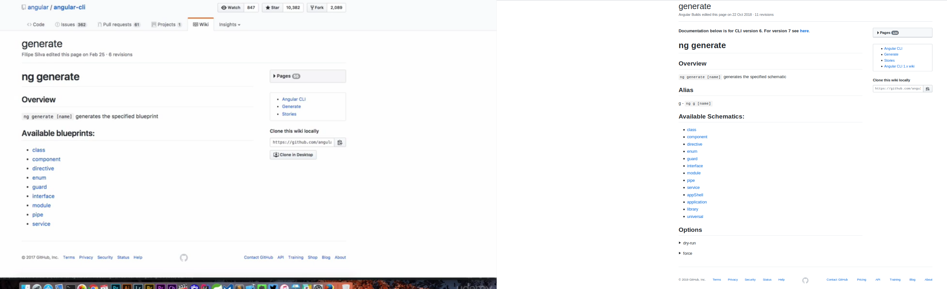

II.) Bootstrap:

- bootstrap: labels:
in 'https://v4-alpha.getbootstrap.com/migration/#labels-badges-and-tags' they claim, 'badge'-component was dropped and 'label' was renamed in 'tag';
in 'https://getbootstrap.com/docs/4.3/migration/#labels-and-badges', there is no 'tag' any more.
No 'label' can be found in the Components section.
No 'tag' can be found in the Components section.
With a search for ".label" you will find
- Progress / Labels (https://getbootstrap.com/docs/4.3/components/progress/#labels)
- Forms / Checkboxes and radios > without Labels (https://getbootstrap.com/docs/4.3/components/forms/#without-labels)
- Forms / Layout > Form grid > Horizontal form > Horizontal form label sizing (https://getbootstrap.com/docs/4.3/components/forms/#horizontal-form-label-sizing)
- Button group / Basic example > Ensure correct role and provide a label (https://getbootstrap.com/docs/4.3/components/button-group/#ensure-correct-role-and-provide-a-label)
You'll find the Badges in Components.
So, at the moment 'label' and 'tag' components have still been replaced with 'badges'
-

